NATIONAL INSTITUTE OF TECHNOLOGY KARNATAKA

DEPARTMENT OF

INFORMATION TECHNOLOGY



MINI-PROJECT

TITLE : Social Networking System - Socio

COURSE : Object Oriented Analysis and Design

Submitted to : Mr. SHRIDAR Sir

Submitted by : Shreyas Shankar (16IT138)

Siddhant Waghjale (16IT148)

**Declaration**

We hereby declare that the project work is entitled “*SOCIAL NETWORKING SYSTEM”* has

been prepared by us during the Even Semester 2017-2018 under the guidance of Mr. Shridar,

Department of Information Technology.

We also declare that this project is the outcome of our own efforts. We also confirm that, the report

is only prepared for our academic requirement not for any other purpose. The information

incorporated in this project is true and original to the best of our knowledge.

Shreyas Shankar - 16IT138

Siddhant Waghjale - 16IT148

**Table of Contents**

**1.Introduction 4**

**2.Abstract 5**

**3.**[**Over**](https://docs.google.com/document/d/1jYBs3OZU8bs3J8FW6fpi4QmH_Tam_fAIN7gDvJHiaEU/edit#heading=h.b6lbr0z8gpcs)**view**

**4.System Requirements 5**

[**Hardware Interfaces**](https://docs.google.com/document/d/1jYBs3OZU8bs3J8FW6fpi4QmH_Tam_fAIN7gDvJHiaEU/edit#heading=h.x6q89jvzlst3)

[**Software Interfaces**](https://docs.google.com/document/d/1jYBs3OZU8bs3J8FW6fpi4QmH_Tam_fAIN7gDvJHiaEU/edit#heading=h.vhqvjq339w4g)

**5.UML Diagrams 6**

**Class diagram**

**State Chart diagram**

**Activity diagram**

**Sequence diagram**

**Collaboration diagram**

**Component diagram**

**Deployment diagram**

**Use Case diagram**

**5. Functionalities 14**

**6. Future Development 14**

# **Introduction**

This document details the documentation for “Social Networking System - Socio”. Socio is a social networking app where users can create their accounts for free and socialize with others. The primary aim of the document is to detail out/ describe the whole system and clearly lists all its functionalities.

This document is meant for any user around the world who likes to socialize but is bound by geographical or any other barriers.

The main purpose of this document is to describe the features and behavior of the system. It includes a variety of elements that attempts to define the intended functionality required by the user’s system.

The system’s functionality is further described in terms of UML diagrams which include Use Case, Class, State, Activity, Sequence, Collaboration, Component and Deployment diagrams.

# **Abstract**

The aim is to implement a social networking system where users can login, make friends, chat with them, share some posts with them. The user can send friend requests to other users and can even make a group with some number of friends. The posts of that group will be visible to only the group members. Additionally, users will have an option to like or dislike a post.

**Implementation Idea**: Each user would be an object with states defining its profile and behaviour including liking a page or sending messages. Posts would again be objects with attributes like content, author, likes, dislikes etc. The users would chat using message passing between different user objects and this message would be an object too. Now, the members of a group would be aggregation and its posts would be composition of the group.

# **Overview**

Socio is a free social networking platform open to users all over the world. The platform allows users to create an account for free and start socializing.

Users can send friend requests to other existing users. The user can communicate with his/her friends via messages. Users can also create posts which would be visible to his/her friends only who can like or comment on these posts. Users can create a group and add members to it. The group has its own posts which are shared only among the group members.

There is also an option for chat. The user can chat with his friends or within his group by entering the respective chat room.

# **System Requirements**

## **3.1 Hardware Interfaces**

The System shall be deployed on Heroku Platform. All the Stakeholders are supposed to log-in into the Socio website where there will be a specific URL to access the System.

Hardware Requirements for stakeholders:

* Pentium 4 processor or higher
* Approximately 100 MB of free harddrive space
* Minimum 128 MB RAM

Hardware Requirements for hosting:

* Minimum 1GB database space
* Minimum 2GB RAM

## 

## **3.2 Software Interfaces**

Software Requirements for Hosting:

* Django 2.0
* MySQL

Software Requirements for Users:

* Browser ( Google Chrome, Mozilla Firefox, Safari etc.)
* Operating System supporting the above browsers.

# **UML diagrams**

## **5.1 Class Diagram**

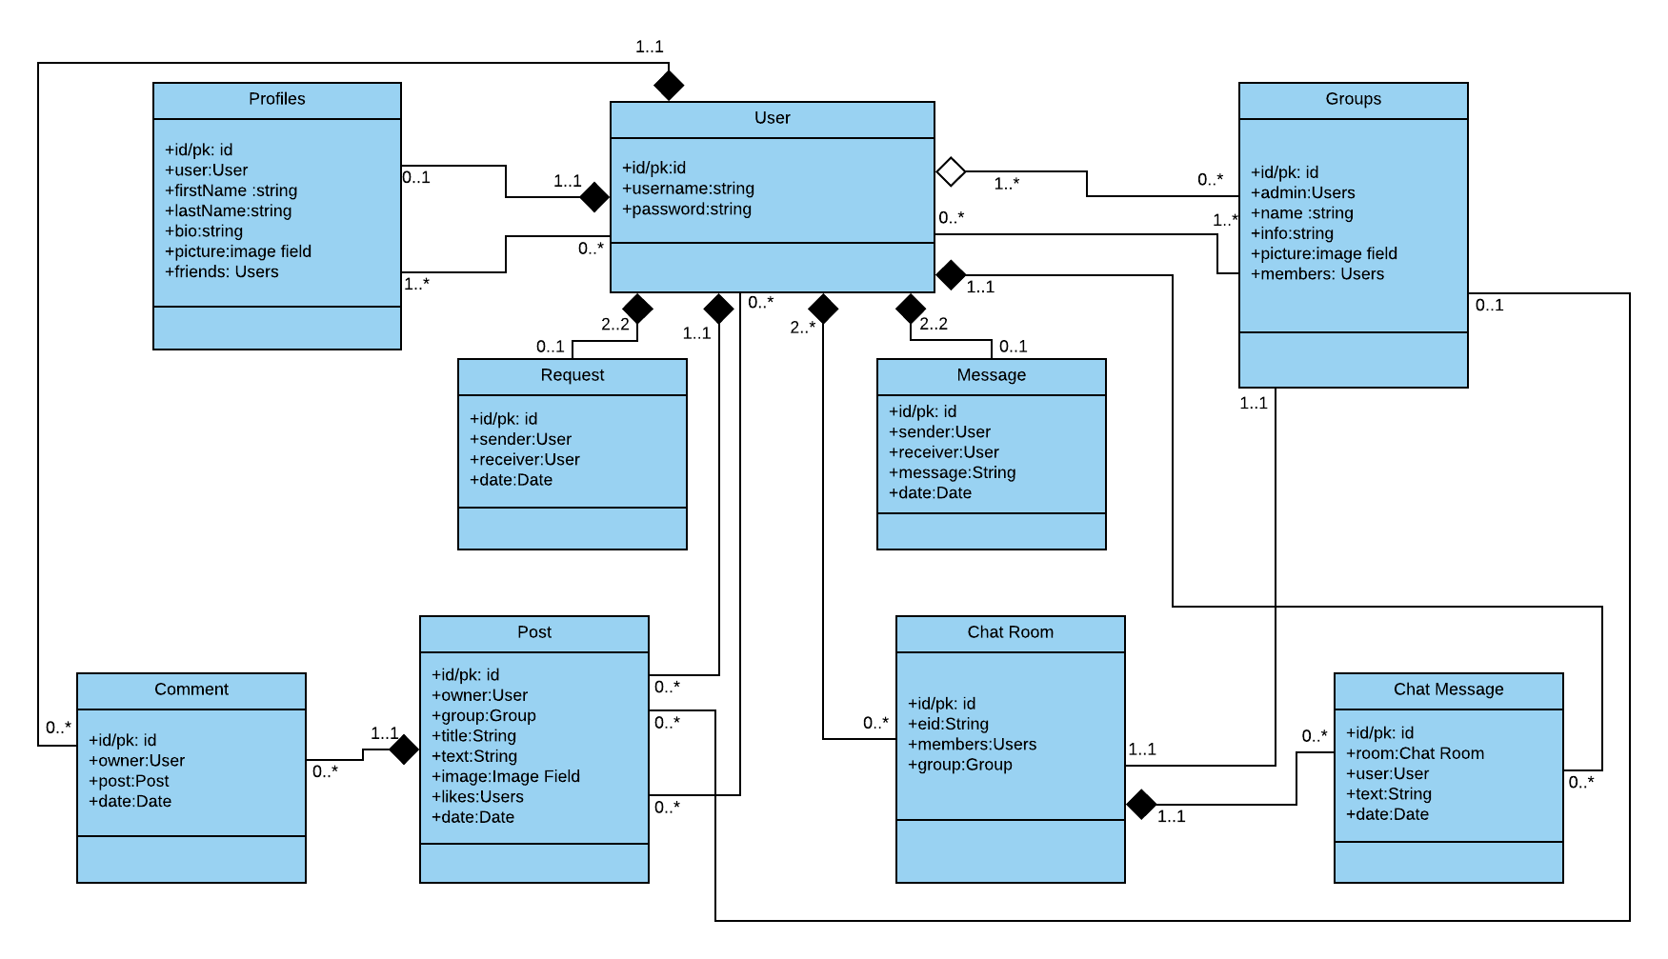

## **5.2 State Chart Diagram**

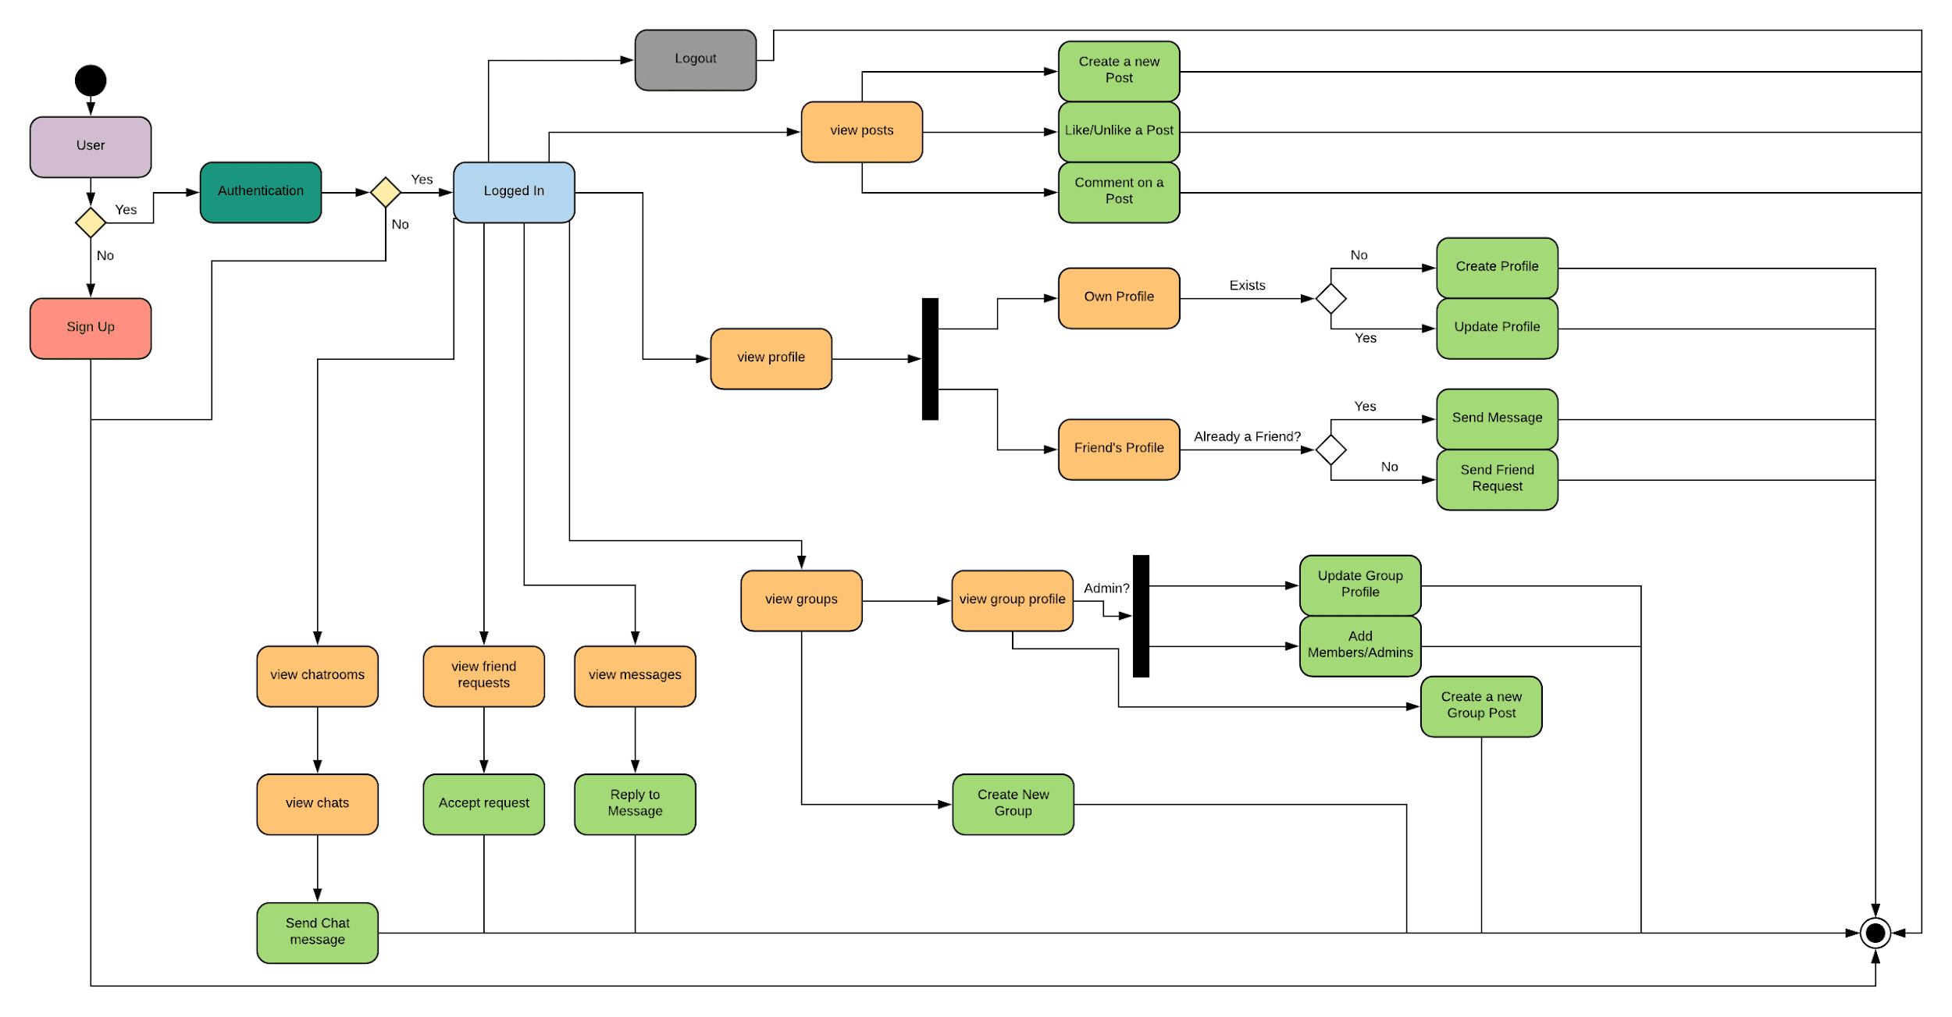

## **5.3 Activity Diagram**

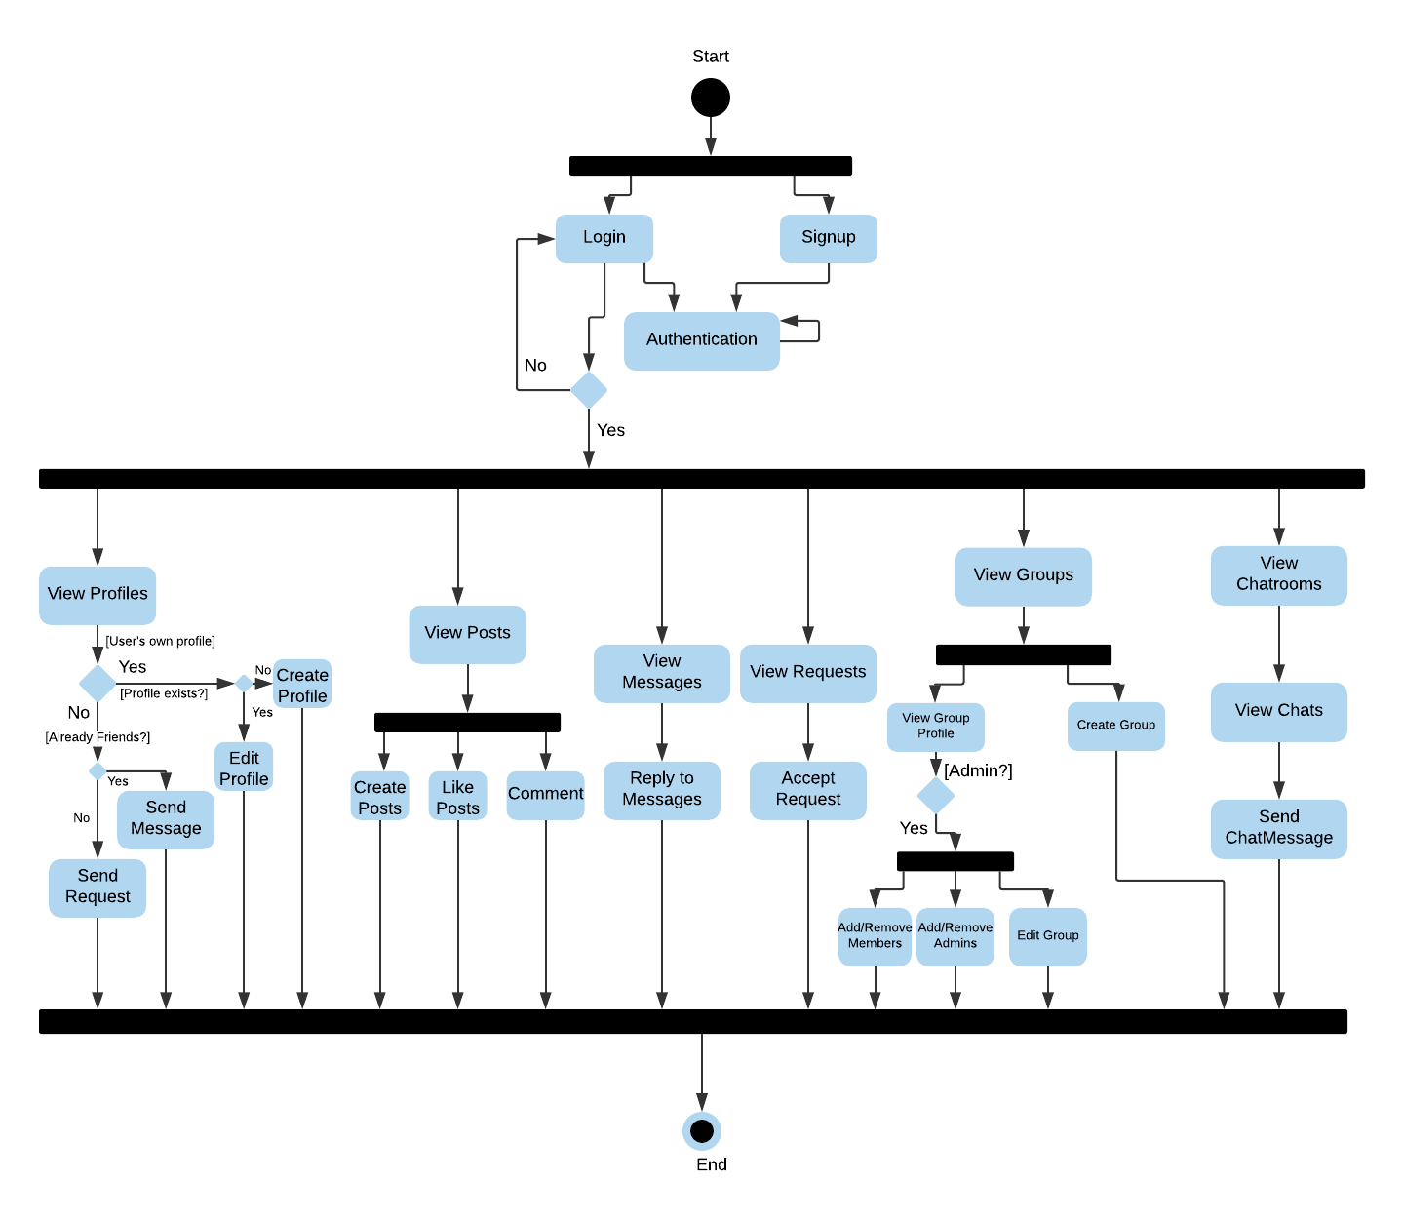

## **5.4 Sequence Diagram**

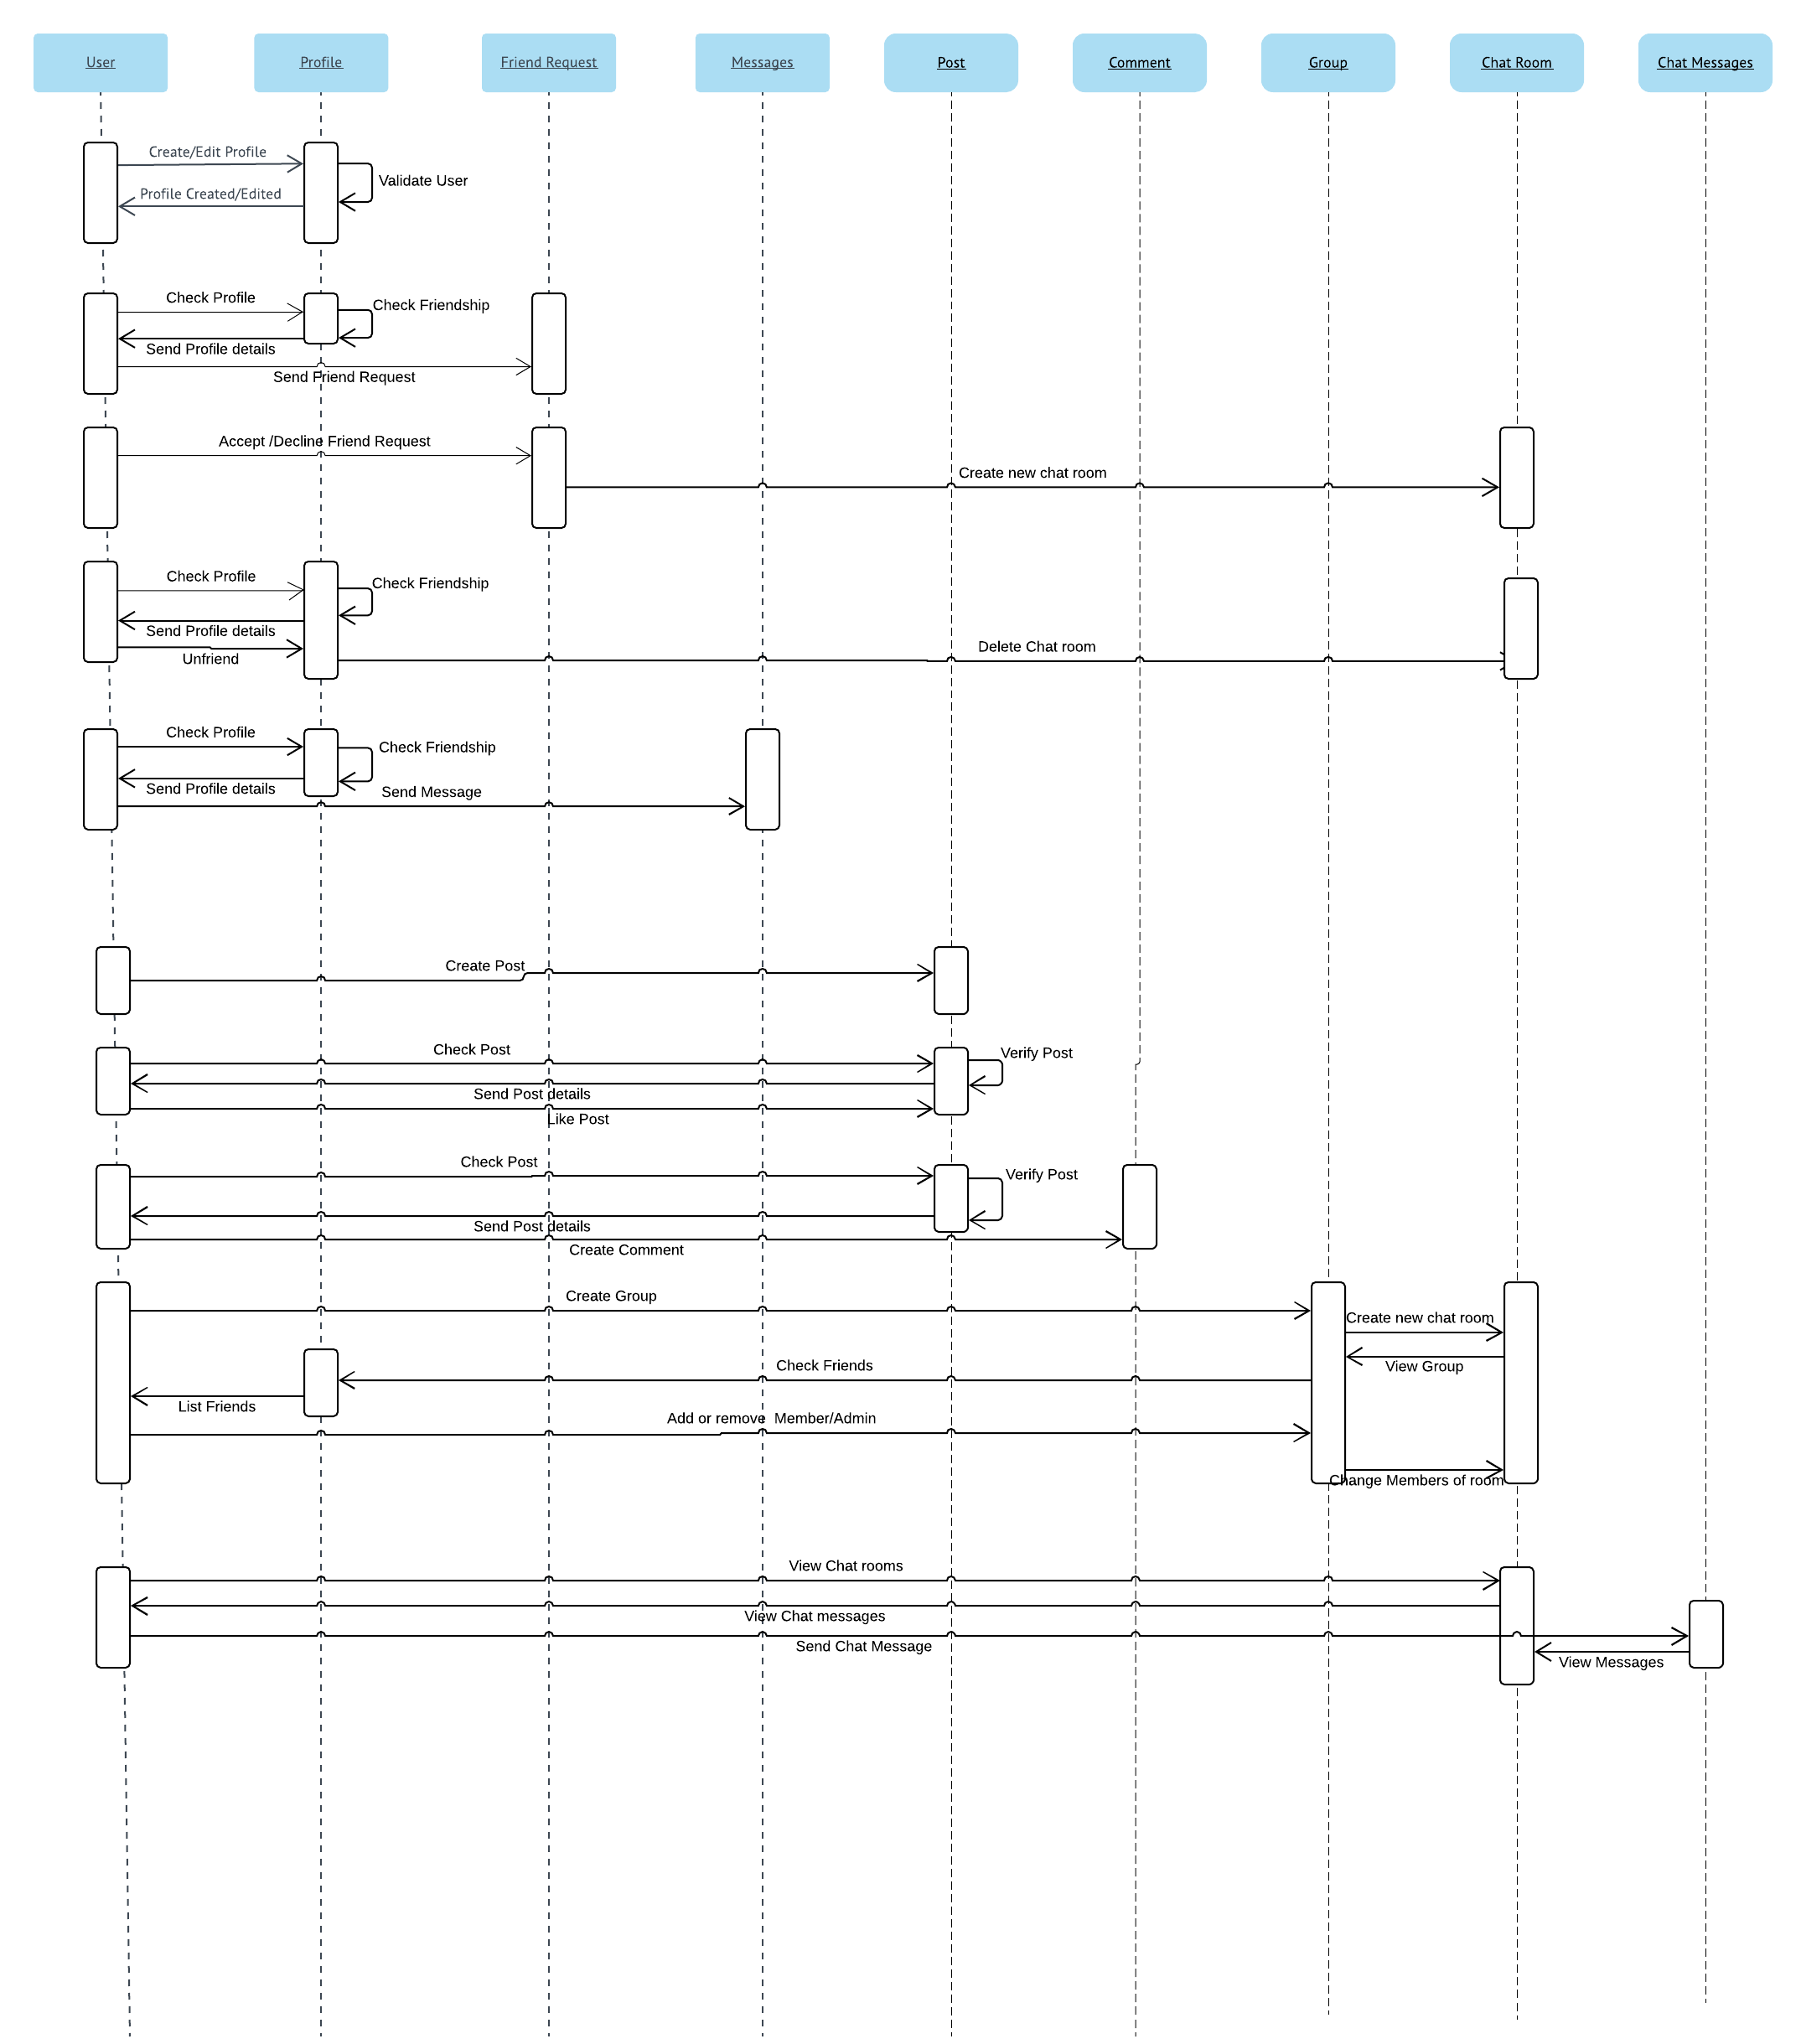

## **5.5 Collaboration Diagram**

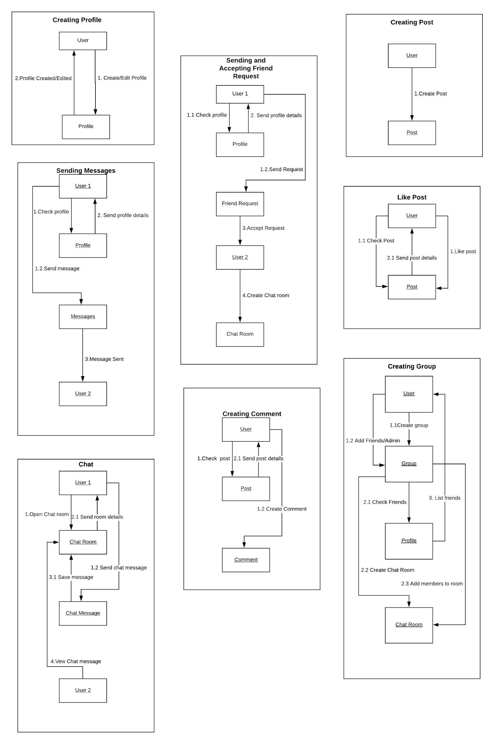

## **5.6 Component Diagram**

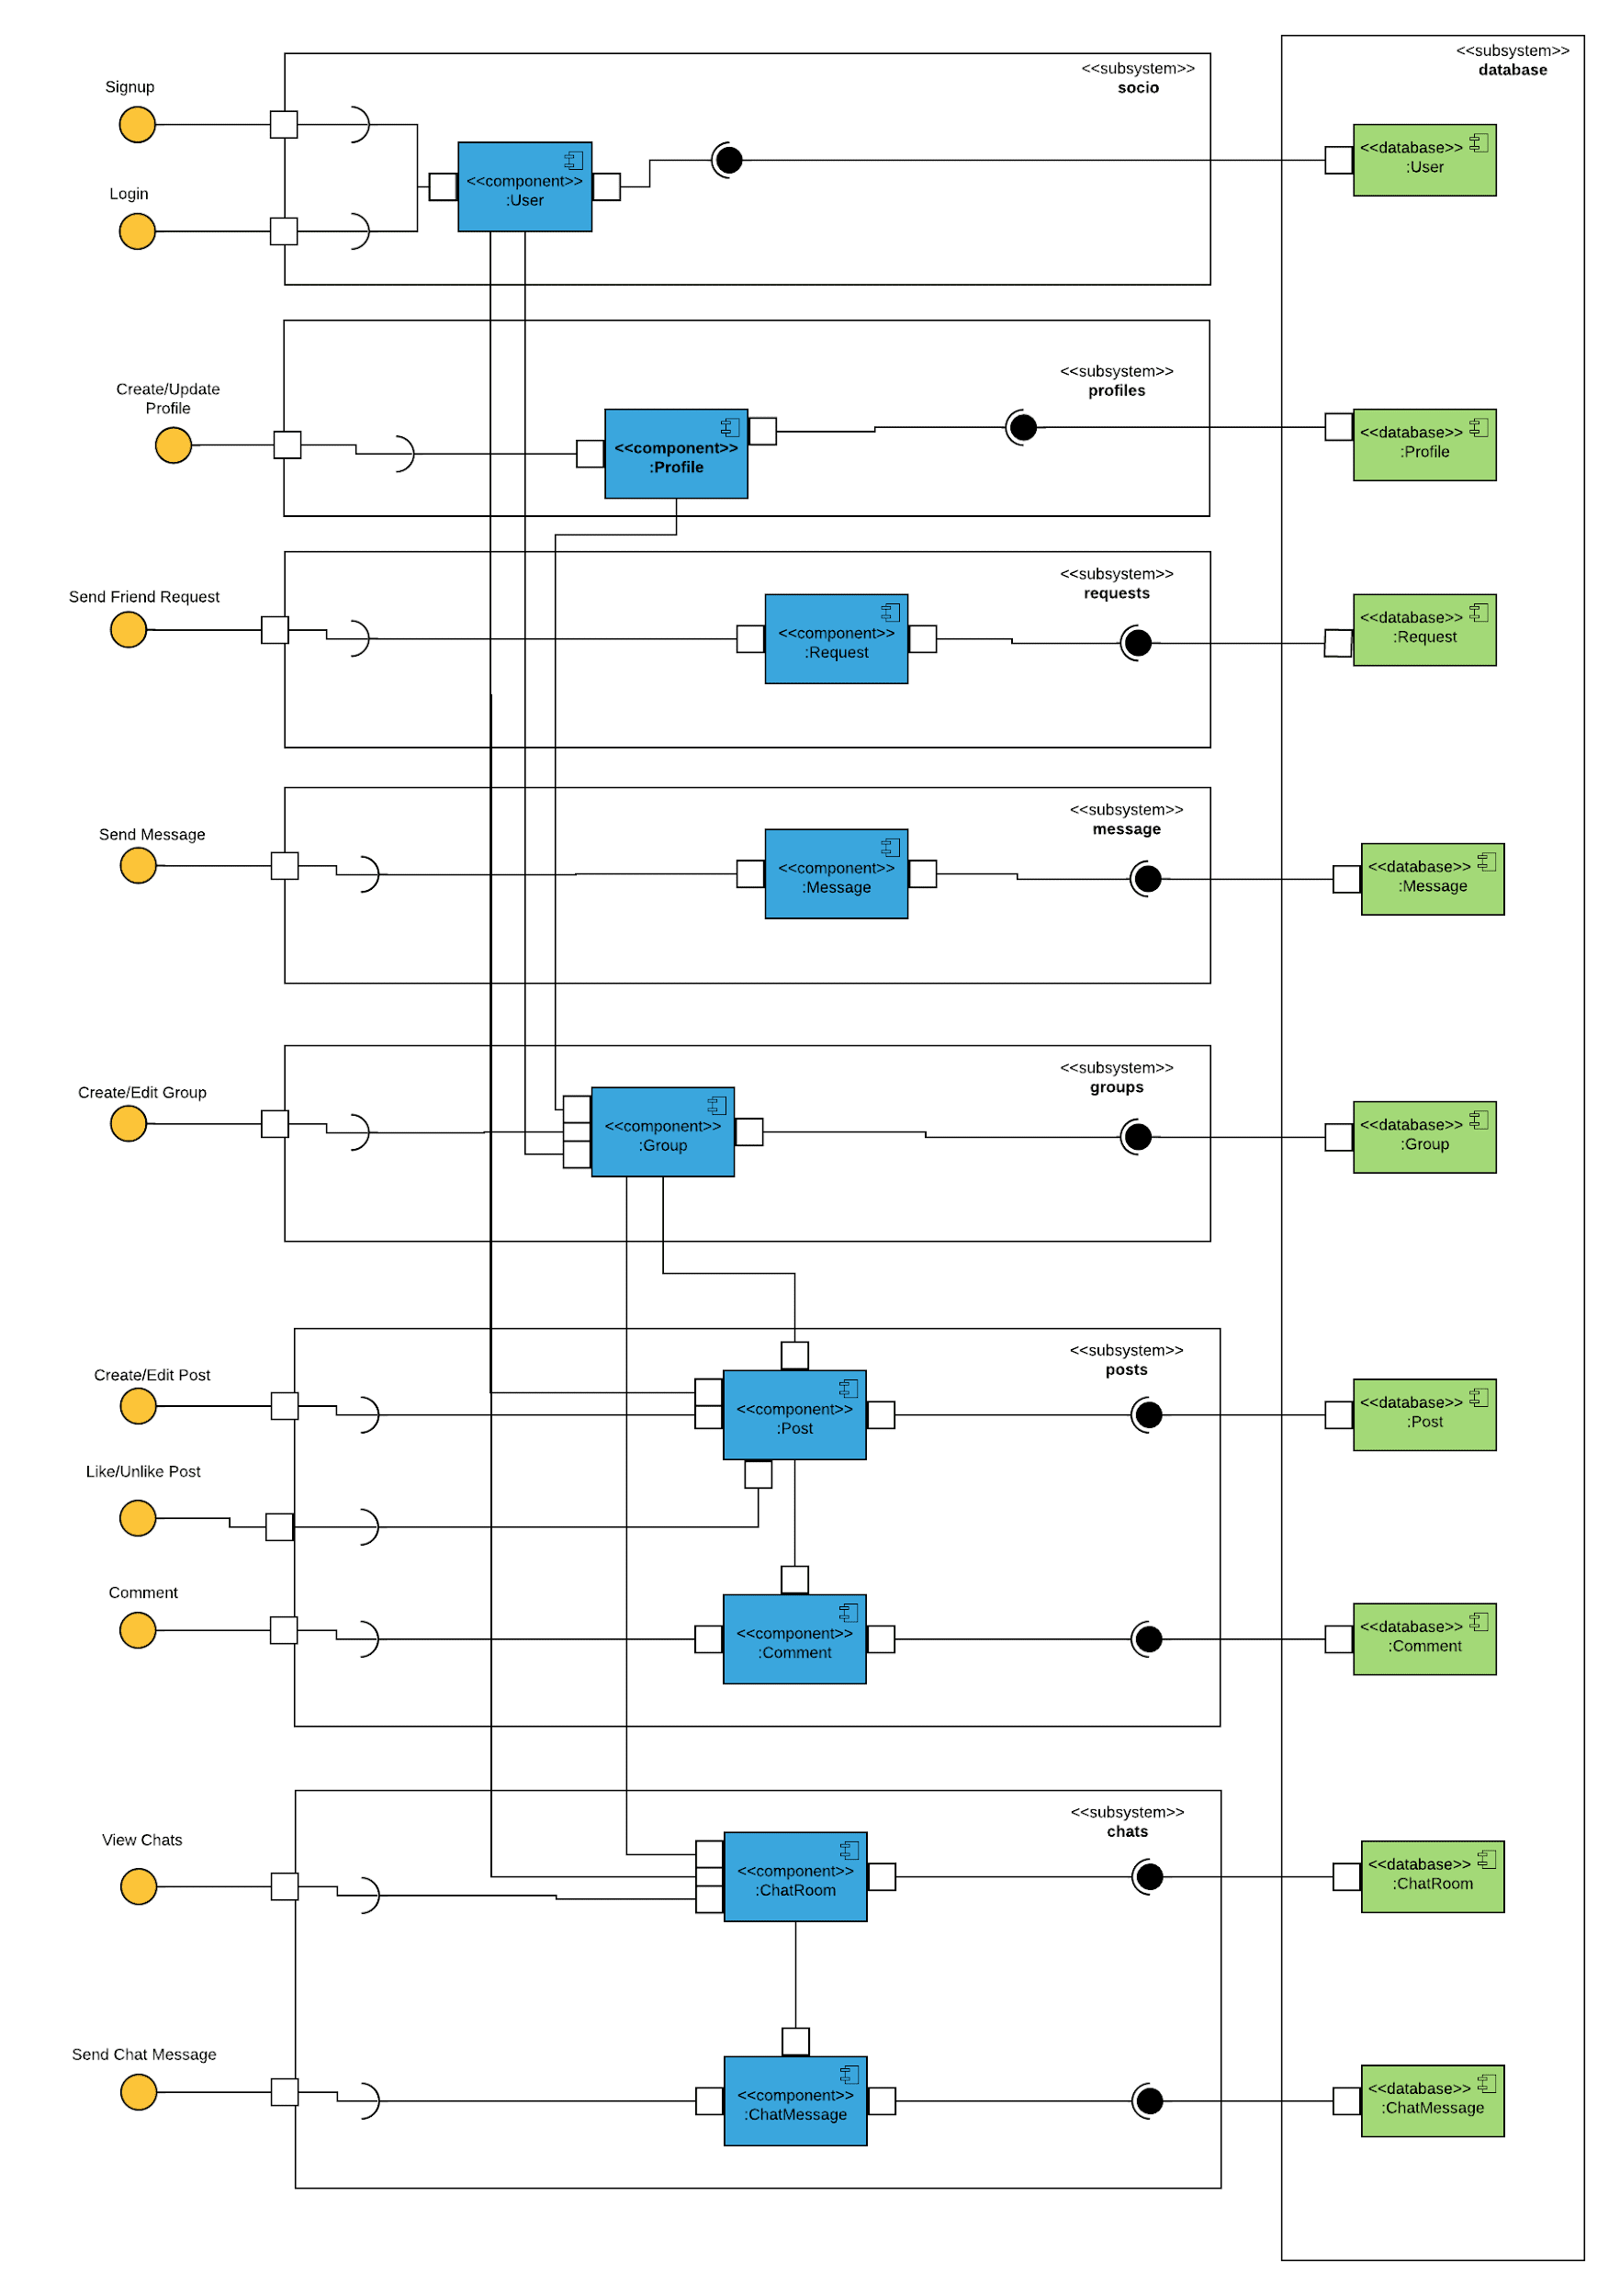

## **5.7 Deployment Diagram**

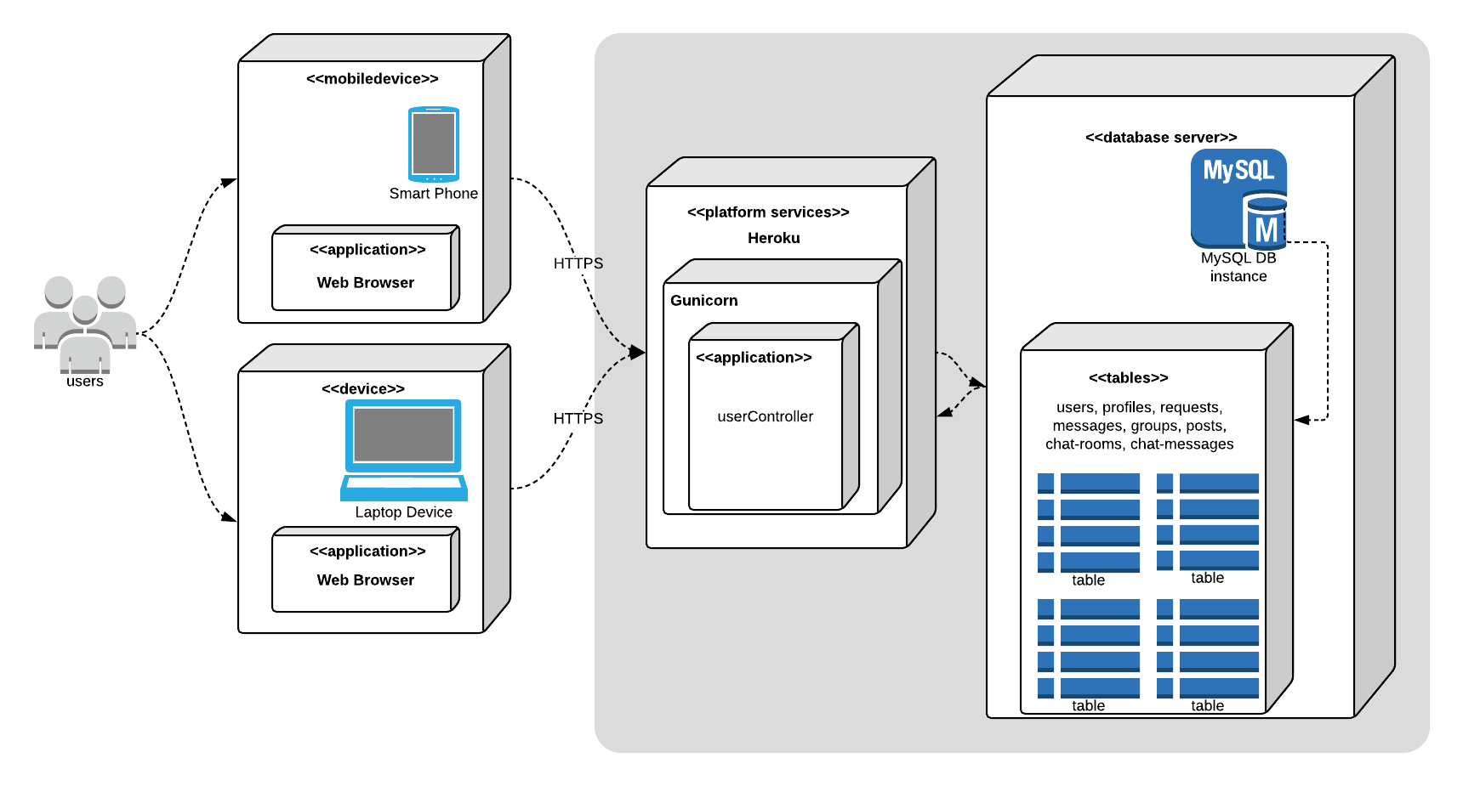

## **5.8 Use Case Diagram**

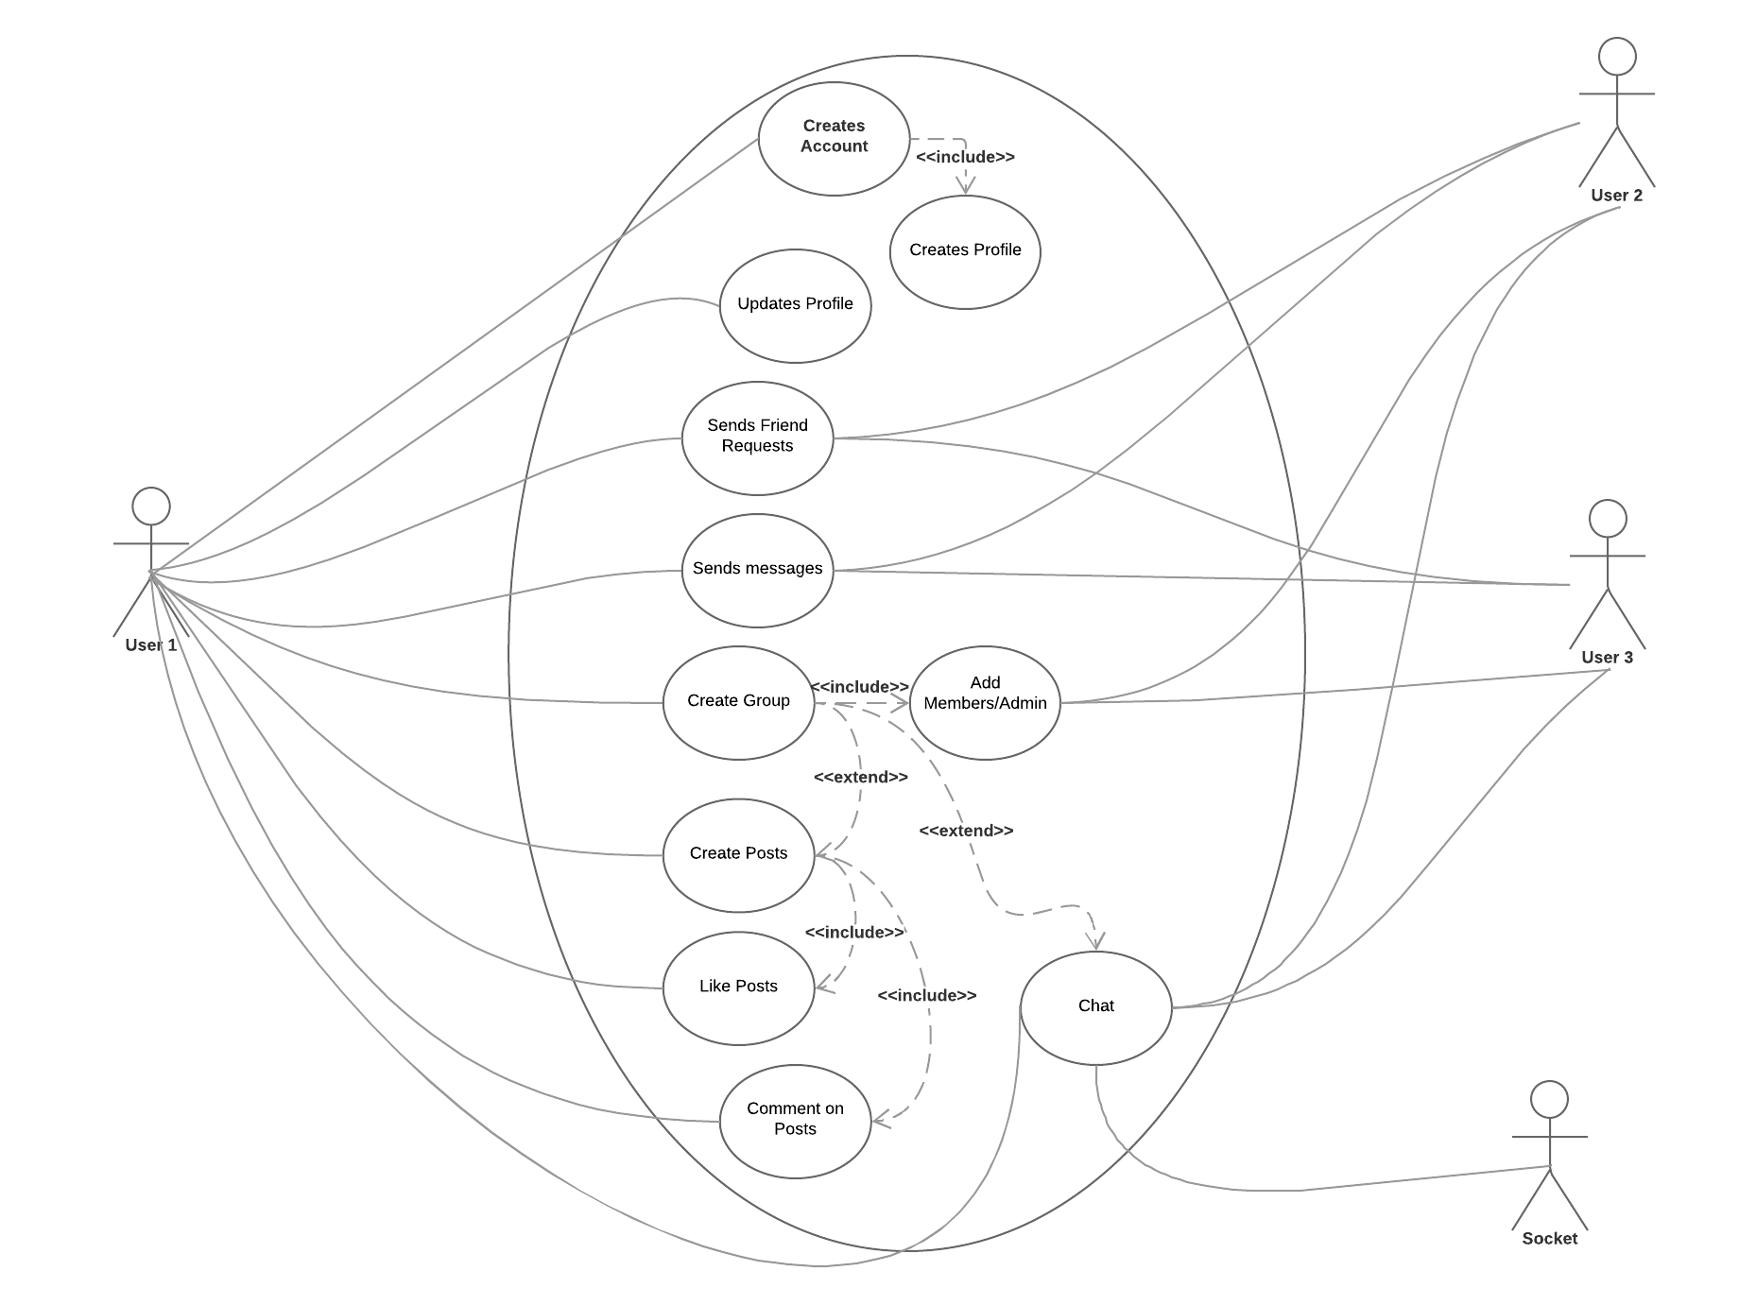

# **Functionalities**

1. Creating Account: The homepage redirects to a login page where the user is prompted to either login or signup. Signup is free.

1. Creating/Updating Profile: The profile page shows the profile of the specific user. The user can edit his own profile from this page.

1. Making Friends: On visiting profiles of other users, there is an option of sending a friend request to that user. If the user accepts your request he is added to your friend list.

1. Messaging: Users can communicate among his friends by messages. On visiting the profile of his friend there is an option to send a message. The messages show up in the messages view of that user.

1. Unfriend: Users can unfriend other users by selecting an option of unfriend present again in the profile view.

1. Groups: User can create groups and add as many members to it as he likes. He can also give admin status to them or remove them from the groups.

1. Posts: Users can either create posts in their own profile or on the group. The posts created on the own profile are reflected on his own profile and also on the posts page of his friends. The posts created on group are reflected on the own page and are visible only to the members of the group. The users to whom the posts are visible can like or comment on the respective posts.

1. Chat: Users can chat with his friends or with the entire group by visiting the respective chat rooms. The chat rooms are created once a friend request is accepted or when a group is created.

# **Future Development**

* We intend to enable Google sign in using firebase.
* We intend to increase security of the user credentials using encryption.
* Add some new features like adding photos to profile.
* Enable voice/video chat using some APIs.